Zheng Wang

COM SCI 32

Professor David Smallberg

June 4, 2018

**Homework 5**

Question 1

1. 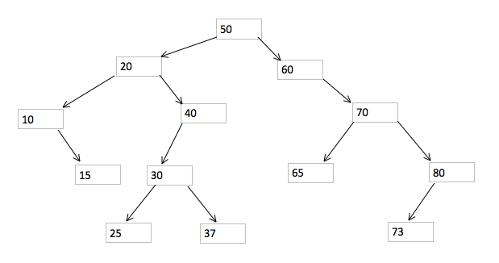
2. The in-order traversals: 10, 15, 20, 25, 30, 37, 40, 50, 60, 65, 70, 73, 80. The pre-order traversals: 50, 20, 10, 15, 40, 30, 25, 37, 60, 70, 65, 80, 73. The post-order traversals: 15, 10, 25, 37, 30, 40, 20, 65, 73, 80, 70, 60, 50.
3. 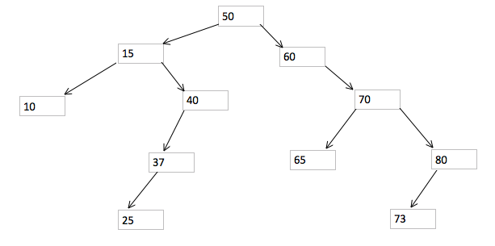

Question 2

1. 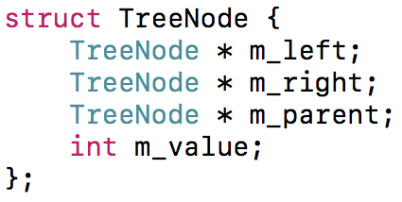

//for general insertions, if the third parameter is not provided, then insert at the root

void insert(TreeNode*& node, int value, TreeNode* parent = nullptr){

if node is nullptr

set node point to new TreeNode;

set node->m_value to value;

set node->m_parent points to parent;

set node->m_left and m_right point to nullptr;

else if value is larger than node->m_value

insert(node->m_right, value, node);

else if value is less than node->m_value

insert(node->m_left, value, node);

else //if this value already exists in tree, do nothing

return;

Question 3

1. 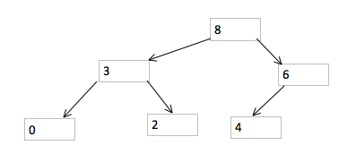
2. 8 3 6 0 2 4
3. 6 3 4 0 2

Question 4

1. O( C + S )
2. O( (log C) + S )
3. O( (log C) + (log S) )
4. O( log S )
5. O( 1 )
6. O( (log C) + S )
7. O( (S*log S) )
8. O( C*(log S) )